

The Complete Title of the Project

Final Report

Project Members/IDs

Alaa Hani (13001246)

Aditya P. Bhagchandani (13001245)

Shehab Alabd (16001397)

Project Supervisor(s)

TA Mohamed Madbouly

Department of Mechanical Engineering

Faculty of Engineering

German International University

# Declaration

We certify that this project work titled “*Autonomous Robot Maze Navigation System”* is our own work. The work has not been presented elsewhere for assessment. The materials that has been used from other sources have been properly acknowledged/cited.

Project Members

Alaa Hani (13001246)

Aditya P. Bhagchandani (13001245)

Shehab Alabd (16001397)

# Plagiarism Certificate (Similarity Report)

This project report has been checked for Plagiarism. A similarity report, endorsed by the Supervisor(s), is attached.

Project Members

Alaa Hani (13001246)

Aditya P. Bhagchandani (13001245)

Shehab Alabd (16001397)

Signature of Supervisor(s)

# Copyright Statement

* Copyright in text of this project report rests with the student authors. Copies (by any process) either in full, or of extracts, may be made only in accordance with instructions given by the authors and lodged in the Library of GIU. Details may be obtained by the Librarian. This page must form part of any such copies made. Further copies (by any process) may not be made without the permission (in writing) of the authors.
* The ownership of any intellectual property rights which may be described in this project report is vested in GIU’s Departments of Electrical & Mechanical Engineering, subject to any prior agreement to the contrary, and may not be made available for use by third parties without the written permission of the GIU’s Departments of Electrical & Mechanical Engineering, which will prescribe the terms and conditions of any such agreement.
* Further information on the conditions under which disclosures and exploitation may take place is available from the Library of GIU, Egypt.

# Acknowledgements

This page can be used to acknowledge any technical or financial support and collaboration with academic, industrial or funding partners, support from supervisor, other faculty members, and/ or other fellow students. Students may also include acknowledgements of family members. Font, line spacing, and page margins must not be changed throughout this section and other sections in the report. Example texts for acknowledgements are given below.

Alaa Hani (13001246)

Aditya P. Bhagchandani (13001245)

Shehab Alabd (16001397)

“Dedicated to our parents and friends and siblings who support us accomplishment, also the TAs and Drs. and GIU Berlin to provide us with any equipment required”.

# Abstract

The objective of this project was to navigate a TurtleBot3 Waffle robot through a maze. The maze was first photographed using a mobile device, then was processed using an algorithm using Open CV, an open-source library. The images were then used to form a map of the maze, which was then put through a path planning algorithm to find a route from the starting position of the robot to the exit. This stage is important in order to find a collision-free path through the maze by employing a wall tracking algorithm.

After the path has been found, a trajectory planning algorithm is implemented to transform the planned path into movement commands for the TurtleBot to follow. This made sure that the robot was conscious of its dynamic constraints such as its acceleration, turning radius, and maximum speed while following the path.

Python and the Robot Operating Software (ROS) were used to integrate the components. This was crucial for the navigation task. ROS facilitated the communication between the components, such as the TurtleBot’s motors, the path planning module, and the TurtleBot3's control module.

During the phase of path planning, the wall tracking algorithm was run on the processed map, which continuously follows the left wall to the exit point. The trajectory planning phase controlled the speed based on its proximity to the next stopping point, as well as its rotation to the required angle, while ensuring that the robot’s kinematics are taken into account.

To evaluate the performance of the system, extensive performance was conducted. The tests were designed to assess the accuracy of the both algorithms and their effectiveness. The TurtleBot successfully navigated the maze, exemplifying the capability of the system. This project demonstrates the effect of combining computer vision, path planning, and trajectory planning algorithms to achieve autonomous navigation in complex environments.

Extensive testing was conducted to evaluate the performance of the system. The tests were designed to assess the accuracy of the path planning and the efficiency of the trajectory execution. The TurtleBot3 successfully navigated the maze, demonstrating the feasibility of the integrated system. This project exemplifies the potential of combining computer vision, path planning, and trajectory planning algorithms to achieve autonomous navigation in complex environments.

**Key Words:** *Autonomous Navigation, Computer Vision, Contour Detection, Image Processing, Localization, Maze Navigation, Morphological Operations, OpenCV, Path Planning, Robot Operating System (ROS), Robotics, TurtleBot3, Trajectory Planning, Wall Tracking.*

# Table of Contents

Declaration i

Plagiarism Certificate (Turnitin Report) ii

Copyright Statement iii

Acknowledgements iv

Abstract vi

Table of Contents vii

List of Figures ix

List of Tables x

CHAPTER 1: INTRODUCTION 1

1.1 Background 1

1.2 Problem Statement 1

1.3 Aims and Objectives of the Project 2

1.4 Significance, Scope and Definitions 2

1.5 SWOT/BOCR Analysis 2

1.6 Report Outline 2

CHAPTER 2: LITTERATURE REVIEW 3

2.1 Historical Background 4

2.2 Topic 1 4

2.2.1 Inserting Tables 4

2.2.2 Inserting Figures 4

2.2.3 Inserting Equations 5

2.3 Topic 2 5

2.4 Topic 3 5

2.5 Summary and Implications 6

CHAPTER 3: METHODOLOGY, DESIGN AND ANALYSIS 7

3.1 Methodology 7

3.2 Research Design 7

3.2.1 Design Alternative 1 7

3.2.2 Design Alternative 2 7

3.3 Software and Hardware 8

3.4 Analysis 8

3.5 Ethics and Limitations 8

CHAPTER 4: IMPLEMENTATION 9

4.1 Hardware Implementation 9

4.2 Software Implementation 9

4.3 IEEE Standards 9

CHAPTER 5: EVALUATION 10

5.1 Heading 1 10

5.2 Heading 2 10

5.3 Heading 3 10

CHAPTER 6: CONCLUSION AND FUTURE WORK 11

6.1 Conclusion 11

6.2 Future Work 11

REFERENCES 12

APPENDIX A 13

# List of Figures

Figure 1

Figure 2

Figure 3

Figure 4

Figure 5

Figure 6

Figure 7

Figure 8

Figure 9

Figure 10

# CHAPTER 1: INTRODUCTION

## Background

Our objective was to develop a robot capable of navigating from one point to another using trackers, with the only inputs being the wall colors and the robot's dimensions. The system includes a calibrated camera and a goal tracker to facilitate this process. This concept was inspired by the "Aerial View Based Guidance System" [1], which employed an unmanned aerial vehicle (UAV) to capture aerial images and was tested on 2D mazes. Drawing from this approach, we aimed to adapt and refine it for ground-based navigation within a defined environment. Our goal was to create a robust guidance system that leverages visual input to determine optimal paths and ensure precise maneuvering through the maze.

In recent years, the inclusion of robots and artificial intelligence into school education has been on the rise, driven by the demand for technology literate students. Our project follows this trend through the implementation of practical applications of robotics and image processing. Through the use of languages such as OpenCV, Python, and ROS, students learn critical skills required in today’s technology focused world. This project also encourages interdisciplinary collaboration, problem-solving, and teamwork, as well as mixing the three disciplinary areas of computer science, engineering, and mathematics.

Furthermore, significant social concerns are raised due to the integration of robots in current day to day life. A major issue is the impact on employment, as various jobs in multiple industries could find many employees displaced due to the automation of their job. Projects such as ours highlight new job opportunities is new and different fields related to robot maintenance, programming, and supervision.

Another social concern is the accessibility of said advancing technology. Providing educational institutions in less privileged areas, along with the resources to teach courses related to robotics and other advancing fields, is essential. Our project aims to serve as a model that can be replicated and adapted for various educational settings, promoting inclusivity and equal access to current technologies.

## Problem Statement

Our study’s main focus is the development of a mobile robot that can autonomously navigate through a maze using only the given image of the map and its own dimensions, through the integration of image processing and path and trajectory planning. One of the major difficulties is in allowing the robot to navigate effectively and efficiently with minimal feedback, meaning without any sensors to check the current location or orientation of the robot. This introduced a great many challenges in decision making and processing. Furthermore, the effectiveness of the map image filtering process in imperfect conditions, such as poor light and blemished floors, was imperative for the guidance system, therefore becoming a critical issue. This project also strives for accessibility for financially less fortunate areas, which was another obstacle that had to be overcome. Additionally, since many educational institutions, whether that be schools or universities, lack the required funds and capital to provide students practical experience with current state of the art technology, there is a need to bridge that gap with regards to robotics and artificial intelligence. Our project attempts to offer students the opportunity to learn these fields and advance them through a repeatable framework using their own unique ideas that they achieve through their life experiences.

## Aims and Objectives of the Project

The main objective of the project is to develop a demonstrable system for the autonomous navigation of a robot through a maze. The project shows a way to navigate through a robot in a way that is very efficient, without the use of real-time feedback, and with a preprocessed map data technique that will be used to create and implement a system for navigating through a maze. The methodology will assess whether a preprocessed data-driven navigation technique proves to be viable and effective for reducing the complexity and expense that would otherwise be involved in real-time sensor integrations.

1. **Marker Production and Placement**:

* Create locators to indicate important locations or points in the environment while navigating the maze.
* Markers should be located on the robot, objective, and on the four corners of the maze to help in precise localization.

1. **Camera Calibration and Image Capture**:

* After adjusting the focus of the calibrated camera, the OpenCV chessboard images with a size of 9 by 6 were analyzed against the camera to verify image accuracy.
* With the IP Webcam app, which turns your smartphone camera into an IP webcam broadcast, you can take a calibrated picture of the maze.

1. **Image Processing and Map Creation:**

* Determine the position of the markers in the obtained image, and export the positions to a CSV.
* Use perspective control to adjust the perspective of the image to straighten the robot and exit into the correct positions.
* Make a binary map of the maze, adopting the dimensions of the robot, to indicate the exit position and encode walls and empty spaces as ones and zeroes, respectively.

1. **Pathfinding and Navigation:**

* Implement different path-finding techniques, like wall tracking, according to the situation, in order to find the best path to take from the robot's current location to the target destination, as well as filter to optimize the pathway.
* Implement trajectory tracking to control the speed of the robot throughout the path.
* Check that the robot can still navigate the map without receiving real-time sensor input.

1. **System Evaluation and Validation:**

* Assess the accuracy, efficiency, and reliability of operation of the maze navigation system.
* This finding and the goals will be matched against one another; the latter state that the robot can effectively navigate the maze with only preprocessed inputs.

**Research Problem:**

Can a robot navigate a maze using only preprocessed map data, and therefore not need real-time sensor feedback? These are the key research questions the project is designed to solve. The hypothesis is set up in the way that it questions the traditionally held reliance on real-time data sources for autonomous navigation and seeks to establish if preprocessed data alone can provide sufficient precision and dependability.

**Objectives To Be Achieved:**

* Determine if the required information for accurate navigation can be obtained from the pre-processed map data.
* Develop and implement a firm system architecture that will allow for navigation using preprocessed data.
* Investigate reliability, performance, and accuracy of the navigation system through several maze configurations.

## Significance, Scope and Definitions

The main significance of this research is in tackling the challenge of autonomous navigation of mobile robots with minimal sensory feedback. Traditional navigation systems most commonly use multiple sensors such as LiDARs and/or other sensors in combination or pervasively pre-mapping the area that the robot will be navigating. These methods can be complicated and expensive, however, through focusing on image processing algorithms to filter and cleanup the map beforehand, delivering a clear binary representation for which to run through the path planning, such factors are not as influential, and the process becomes less costly and more accessible. This method is useful in situations where the use of sensors is for any reason not preferred.

This research’s methodology involves the integration of image processing and robot control systems, using OpenCV for image processing and a wall tracking algorithm for navigation through the maze. The reason this research is so important is that it overcomes the complexity of the navigation task through the use of readily available technologies. An application of computer vision in robotics is the enhancement of the characteristics of mazes with an image processing algorithm and a calibrated camera. The research fills a big gap in this field by focusing on a real-time process and decision for an autonomous navigation system.

By focusing on the role of wall colors as visual cues for guiding ground-based robots, the present work makes up for a gap in the literature. Although many studies have been conducted to implement the use of LiDAR, GPS, and other advanced sensors for navigation, the wall tracking algorithms and the simple visual inputs have not been widely researched. This study contributes to the robotics field because it explores the under researched area by suggesting ways and ideas used to implement more affordable and accessible navigation systems. This contribution also proposes a reproducible and modular robotics and AI education system, which may impact the educational methods.

This paper presents the implementation and testing of an autonomous navigation system for an indoor ground-based robot using wall tracking algorithms with visual inputs. The main goals of the project are to develop a camera-based navigation system that uses a calibrated camera to collect visual data, coupled with the use of OpenCV image processing techniques to sense and improve upon the maze features, and then to design a wall tracking algorithm that will indeed guide the robot throughout maze walls. This paper tests the robot's ability to successfully navigate through pre-designed mazes under indoor conditions. Emphasis is towards real-time processing and making decisions to ensure that the navigating task is carried out efficiently and effectively.

The present study is limited to indoor areas with controlled lighting conditions to obtain reliable and consistent visual inputs for the robot's navigation system. The study is limited to maze configurations with wall colors that are different enough so as to be distinguished by the image processing algorithms and that can be captured and processed by a single calibrated camera. The present investigation employs the TurtleBot3 platform because it is available with support for the Robot Operating System (ROS), so it can be used for educational purposes and with a useful, user-friendly interface for the implementation and testing of the navigation system. In addition, the study focuses solely on visual-based navigation, and does not explore or discuss the other sensory inputs, including GPS or LiDAR.

Autonomous Navigation: A robot's ability to move and work on its own, without any external help while deciding on its course of action as a response to its sensory inputs.

Computer Vision: Computers and other systems interpreting digital photos, videos, and other visual inputs to derive important information, a subdomain of artificial intelligence.

OpenCV: an open-source software library for computer vision and machine learning enabling a large set of tools for image processing and computer vision applications—making it simple to develop algorithms in visual analysis and recognition.

Wall Tracking Algorithm: An algorithm that uses visual inputs to be always at a predetermined distance from a wall, allowing a robot to follow the outlines of a wall or boundary to ensure it goes correctly through its path.

Maze Navigation: The action of guiding a robot through a maze, with maze algorithms and sensory inputs, in order to reach a predetermined goal without hitting or damaging an obstacle.

## SWOT/BOCR Analysis

The project takes a new approach in navigation and boosts robotics for a creative solution by utilizing wall tracking algorithms and visual-based inputs. It can be adapted for educational projects since it is cheap and only uses an open-source program called OpenCV and a calibrated camera. It will be a useful learning tool for robotics and artificial intelligence. Since it is a simple system - it combines wall tracking with visual inputs - multi-sensory navigation systems will be less complex, thereby reducing complexity in use and understanding.

However, as its use is restricted to indoors with controlled lighting, the system has less value in many applications. It is less useful in other situations because of its dependence on well-known wall colors and strong visual cues. Also, during navigation, the technically demanding and real-time calculations involved in visual processing and decision-making sometimes fail or get out of pace. The constraints listed above show that testing is important, and that the system optimization process must continue to increase the system's robustness and adaptability.

This possibility is really promising, especially in the field of education, where it can be used to enhance robotics and artificial intelligence courseware and give students useful real-life scenarios. The flexibility and scalability of the system also make it applicable in commercial and industrial use where low-cost navigation solutions are a must. This gives better chances for research and development and the integration of new functionalities in vision-based navigation systems. The possibility of research and academic collaborations that can be used for innovations and disseminations extends its reach and success.

Its project potential is threatened, however, by the risks of rapid advances in robotics and AI that will rapidly render the existing system obsolete if it is not updated frequently; environmental variability, such as changes in lighting and maze layouts, could seriously compromise system reliability and effectiveness; competition with other established as well as emerging technologies that are using cutting-edge sensors, such as LiDAR, could push the project out of the running; and limiting resources in terms of funding and materials could make the development, testing, and deployment of the system harder and ultimately impact the entire success and sustainability.

## Report Outline

Chapter 2 – Literature Review:

1. Historical Background
2. Intelligent Maze Solving Robot Based on Image Processing and Graph Theory Algorithms
3. A Maze Bot
4. Remote Path Planning and Motion Control of Mobile Robot within Indoor Maze Environment
5. Aerial View Based Guidance System
6. Summary and Assumptions

Chapter 3 – Methodology:

1. Methodology
2. Research Design
3. Real-time Sensor Input
4. Wireless Centralized Control System
5. Ethics and Limitations

Chapter 4 – Implementation:

1. TurtleBot Implementation
2. Algorithm Process
3. Challenges Faces
4. IEEE Standards

Chapter 5 – Evaluation:

1. Qualitative Analysis and Technical Assessment
2. Business and Economic Evaluation
3. Social and Environmental Concerns

Chapter 6 – Conclusion and Future Work

1. Evaluation Review
2. Design Review
3. Future Ideas

# CHAPTER 2: LITERATURE REVIEW



## Historical Background

The development of mobile robots and their navigation has a history that is nothing if not fascinating, stretching from early dreams of automatons in ancient civilizations to the complicated, independent systems of today. Although the idea of making mechanical beings had long since been present in the tales and folklore of many cultures, actual robotics applications didn't start until much, much later.

The term "robot" was apparently first introduced in the play "Rossum's Universal Robots" by Czech author Karel Čapek in 1920. Although considerable progress had been made in the field of computer science, practical intelligent mobile robots did not begin to be used until the mid-20th century, during World War II. At the time, they were predominantly used in the military and were mainly for teleoperations.

Advances in AI only really accelerated the field of robots post-war. These allowed robots, with more autonomy and intelligence, to comprehend and perform tasks without assistance. The development of navigation systems – from line-following, teleoperation, and the like to state-of-the-art Simultaneous Localization and Mapping (SLAM) algorithms – outlines how modern robots face and operate in complex environments.

Many industries, including the military and security forces, freight transport, health care, postal delivery, infrastructure inspection, and even passenger transportation, have found applications for mobile robots. One of the ways how this become possible was that, besides technological progress in deep learning and machine learning, AI became more inclined to acquiring the ability to learn and improve.

With the potential development of decision-making autonomy and the ability to adapt to a greater variety of conditions, the future for mobile robots and navigation looks even brighter. These will only become more outstanding machines, of which our daily lives and our industries that fuel globalization, in striving and stretching the limits, will become more dependent.

## Intelligent Maze Solving Robot Based on Image Processing and Graph Theory Algorithms

Aqel et al.'s paper "Intelligent Maze Solving Robot Based on Image Processing and Graph Theory Algorithms" puts forward a new method for maze solving based on artificial intelligence and image processing techniques. From the strong points, it can be mentioned that there is a proper literature review in the paper, from maze-solving algorithms to the methods, a clear account of a proposed system design and implementation, and the way of comparison with the suggested method and the conventional techniques, in terms of time and distance traveled to reach the goal. The way graph theory algorithms have been applied to determine the shortest way around the maze, along with image processing techniques, is in itself a novel application, one that holds promise for application not only in intelligent traffic control but also in the domain of autonomous robots.

However, further details on the experimental design and the test procedure for the study of the developed system would make the study stronger. The discussion of the comparison between the proposed method and the conventional approach would be more convincing by having a more in-depth study of the results and the defects of the proposed method. Moreover, it would be a good idea to mention the issues and challenges during the installation of the system and how they were solved in order to give readers a better insight into the proposed solution.

Employing graph theory algorithms in the maze solving, mainly A*, Best, and Breadth First Search are some of the research methods incorporated in this field. In addition, using a computer software, maze image processing techniques are used to help in the analysis and solving of mazes. Image processing and AI graph theory algorithms are combined to create a suggested methodology that would lead to finding the shortest path through a maze from a certain starting point to a destination point.

Graph theory and image processing are integrated into the new maze-solving technique for this research. This effort can improve robotics and artificial intelligence upon the correction of some identified limitations and with the incorporation of further details and experimental findings [2].

## A Maze Bot

Keselman et al.’s project was using a Puma robot to navigate a ball through a maze, involving vision and real-time feedback. High technical competence was displayed with the ability to use the vision systems for maze-solving and feedback on the ball's position. The application of this resulted in a functional model that could be simulated and used on a real system, thus showing the team's capacity to change abstract ideas into useful applications.

The pixel-level maze solver in Python with a bread-first-search algorithm was another demonstration of the technical capability of the team. Beyond the technical nature of the implementation, it called for an understanding of algorithms and programming that not many other projects would require. The problems the team could solve and the solutions that were feasible to implement were displayed. The ability to fuse the knowledge gained in the theoretical parts of the program with practical problems was displayed through the use of this solver in effectively finding its way around the ball through the maze.

Besides giving the Puma robot the ability to navigate a ball through a maze as intended, the use of vision and real-time input in the grander success of the project, and the technical skill to solve a maze, were also important experiences for the team members. Through the project, the team members were to gain practical skills, understand robotics and control systems better, and get through problem-solving approaches; these would help them in their career in the future.

Among the limitations of the simulations are the ball being erratic due to the low mass value and exhibiting unexpected results and numerical inaccuracies as drawbacks to the project. Moreover, although the maze was fixed at a certain distance from the robot's end effector, it sometimes separated from it, resulting in an inability to keep it attached during the simulations. It was very time-consuming to tune the gains until a balance between being fast and the orienting movements being smooth when completing the mazes was achieved, further emphasizing the need for trajectory generation, so that orientation control can be perfected and provide better pathways for the Puma robot. All of these challenges helped identify the challenges of modeling and implementing real-time feedback systems and identified areas to be improved in future projects.

Trajectory development, which would give the Puma robot smoother routes for orientation control, is one area where this project might use further assistance. The efficiency and accuracy of robot maze navigation can be improved by optimizing the robot trajectory production process. To increase the tracking accuracy and dependability of the project's detection-based tracking method for the ball and maze, a more sophisticated tracking strategy that makes use of Lucas-Kanade tracking and Kalman Filters can be used. The performance and dependability of the vision system can be increased by addressing problems with camera noise and depth data correctness. Nevertheless, tracking mazes are a trade-off of RGBD cameras.

## Remote Path Planning and Motion Control of Mobile Robot within Indoor Maze Environment

There are several strengths of the proposed method for Lutvica et al.'s wireless mobile robot navigation and trajectory planning in a maze environment. Notably, the use of image processing algorithms for orientation, localization, and color detection is a strong technical aspect. As indicated earlier, the algorithms, with the application of BFS and modified DFS algorithms, are used by the system to guide path planning, making it possible to achieve effective trajectory. The study has aptly demonstrated the feasibility of implementing robot motion trajectories. The adopted method was carried out to full scale, thereby showing that the adopted solution was very effective. In addition, the system is demonstrated to have flexibility with respect to different environmental factors, emphasizing the strength of the system in its ability to handle changes in lighting conditions. The general correctness and efficiency of the system are shown in experimental results, even if it was difficult for it to operate due to mechanical problems. The authors have adequately and expertly demonstrated the ability of the system for maze-based environment navigation, thus providing mobile robots with an assured and robust wireless navigation option.

These limitations in this system of proposed navigation for mobile robots wirelessly in a maze setting are not precisely indicated. Almost all particular problems in implementation have not been deeply expressed, especially those that emanate from motion planning and maze encryption. There are also lacking assessments of constraints detected all through the process of experimentation. With such information lacking, it is hard to investigate the problems of the system thoroughly.

A more detailed explanation of the special issues which may be encountered with the implementation phase of the wireless mobile robot navigation system in a maze environment, especially maze encryption and motion planning functions, would be useful to provide an insight into the system limitations and areas requiring further development. Furthermore, conducting a detailed performance analysis and comparison of the proposed system against existing solutions would do a lot to enhance the contribution of the paper to the subject. Such a detailed performance review would give a strong basis for the authors to assess the potentials of the proposed system in practical situations by showing the system's pros and cons.

## Aerial View Based Guidance System

Wasti et al.’s study presents an emergent "real-time optimal pathfinding navigation system" that resolves the critical problem of urban traffic congestion by using a "floodfill algorithm" for rapid path computation. The authors advance a system that is very quick and more efficient than current navigation systems, representing a quantum leap in traffic management technology. Significantly, the use of an aerial camera to offer a "bird's eye view" and the use of "Hyper Text Transfer Protocol (HTTP) on top of 802.11n protocol" for data transport have greatly enhanced the system's ability to properly guide ground vehicles. In addition, the methodology of the paper is robust, using "image processing" and "maze solving" techniques directly feasible for real-world scenarios, hence being a "viable option for future applications". The authors' acknowledgment of the need for "smart navigation" is of a forward-looking strategy and concurs with the future path of urban development and vehicle navigation.

The paper offers a novel approach to guidance but with several failures. Perhaps the most important one is the difficulty in image preprocessing when the authors report: "it was non-trivial to ascertain a universally ideal value to isolate just the walls of the maze…" It means that the achievement of the same conditions of image analysis is quite problematic. Next, the major drawback of the system is calibration by hand: "for our isolated test case, we opted for manual calibration whenever the test apparatus was set against a new setting". After that, the applicability of the system would then be limited in that manual intervention should be avoided in dynamic real-world scenarios. Lastly, the paper speaks about the problem of handling image artifacts and shadows for a reliable and accurate system. In this sense, though there is potential in the system, the practical implementation might need further refinement to deal with these issues.

The research really takes a commendable approach to the problem of navigation. The concept, however, is recommended for further development. The authors recognize the problems associated with image processing, and in particular, with thresholding: "it was non-trivial to ascertain a universally ideal value…" This hints that a more adaptive algorithm could cope with shifting settings. The method is limited by the need for manual calibration. Further automation of the calibration procedure will improve the system's efficiency and usability. Furthermore, with the problem of handling image artifacts and shadows described, advanced image segmentation approaches using machine learning could be applied to enhance the system's accuracy considerably for real-world applicability.

## 2.6 Summary and Implications

Aqel et al. present a novel maze-solving approach based on artificial intelligence, which integrates image processing and graph theory methods. The investigation is well recognized by scholars for thoroughly reviewing the literature, clear design of the system, and comparison with the conventional techniques. The more detailed examination of the results and additional information about the experimental setup would enhance the work.

The study conducted by Keselman et al., revolves around a Puma robot employing real-time input and vision to navigate a ball through a maze. The project shows technical competence, in particular to the Python maze solver which uses the breadth-first search algorithm. It is underscored how adept the team can implement theoretical knowledge towards problems arising in the real world. Limitations including those of the unpredictable behavior of the ball and difficulties in keeping it attached to the end effector of the robot emphasize a necessity for better trajectory generation.

The work of Lutvica et al. concerns wireless mobile robot navigation in mazes, through image processing in order to find and orient it. Even though the robot is highly unreliable, its system is considered very flexible and efficient. The assessment demands a more detailed performance analysis and better justification of implementation issues, specifically of motion planning and maze encoding.

The discussion of Wasti et al.'s work presents the development of a "real-time optimal pathfinding navigation system" to minimize urban traffic congestion through the use of a "floodfill algorithm." The system is described as effective and fast; an aerial camera allows the panoramic view and an HTTP over 802.11n protocol makes rapid data transfer possible. The method used in this research is quite acceptable because it uses image processing and maze-solving techniques that are very appropriate in real applications. The problems with the current research are image preparation, manual calibration, and difficulties with shadows and artifacts in the photographs. The implementation problems require the development of a more adaptive algorithm, increased automation, and the improvement of picture segmentation.

It is evident from our research that the trend in research is in the application of image processing and AI in the navigation of different scenarios: from maze-solving robots to urban traffic management. While the research presented demonstrates unique techniques and technological know-how, they also have their own obstacles in image analysis, calibration, and system improvement. Solving these with more comprehensive experimental designs, adaptive algorithms, and automation has the potential to really drive this field forward and result in more robust and dependable navigation systems.

Through this literature review, there seems to be a gap regarding robot navigation using only preprocessed map data, with no real-time sensor input, which we have chosen as our project. Thus comes our research question: Can a robot be navigated through a maze using only preprocessed map data? The main assumptions used are that the environment is static, meaning that there are no moving obstacles in the maze, and that everything is fixed throughout. Secondly, that the camera is properly calibrated and that everything is correctly aligned. The third assumption is that the markers have been placed accurately and are visible for precise localization. Finally, it is assumed that the pixel to centimeter ratio are fixed, and do not change throughout the map.

# CHAPTER 3: METHODOLOGY, DESIGN AND ANALYSIS



## Methodology

Autonomous Robot Maze Navigation System was picked as it places a strong emphasis on obstacle avoidance and effective pathfinding. This project aims at guiding a robot through a maze without colliding with any obstacles or being trapped. The basic idea is to photograph the maze, and through post-processing software, determine the whole layout and obstacles on the map. The objective of this project is to use the pre-processed maze photographs to guide the robot through the best way by utilizing path and trajectory planning algorithms. A wall tracking algorithm was used to determine the path out to which the robot followed, and its velocity and angular speed are modified in accordance with how far it is from the next stop point and the angle it should get to, respectively. The ability of the system to have the map of the maze preprocessed before the robot begins the movement helps the robot navigate efficiently and accurately. To achieve the developed project in parts that contribute to the success of autonomous robot maze navigation, it was divided into smaller tasks, which include picture preprocessing, wall tracking algorithm development, and trajectory planning algorithm development. For the implementation of each of the above-mentioned tasks, the responsibilities were divided among the team members, the task was researched based on relevant academic articles and practical applications in other robots projects of the same nature. This approach helps the team to mix the theoretical concepts with practical implementation and achieve an efficient and reliable autonomous maze robot navigation system, as well as answer the research question of, can a robot be navigated through a maze using only pre-processed map data.

## Research Design

The design of this research project is primarily qualitative. There is no predetermined, numerical, and quantitative measure produced by this project, such as a performance log; therefore, the project gives a judgmental understanding and observation of the robot's navigational performance. Qualitative technique was chosen due to the nature of the objectives of the project and the type of data at hand.

**Qualitative Approach:**

1. **Observation:**

The primary means for the data to be collected comes through instances of a robot navigating a maze. Follow its movements carefully, and record the final distance of the robot from walls, whether it made a reasonable attempt to follow the intended course, deviated from it, and if any collisions occurred.

1. **Descriptive Analysis:**

The key observations, centering on specific robot behaviors and performance aspects, will be documented in-depth with ample descriptions. This encompasses what extent the robot avoids obstacles, sticks to the desired course specification, or gets stuck in the event of making an error in navigation.

1. **Qualitative Metrics:**

While direct quantitative data will not be available, the collision frequency and severity and the smoothness of the path and general consistency of navigation will be assessed using qualitative cues across many trials. This will give a sense of an empirical approach toward modeling the behavior of the robot's operation.

**Data Gathering Procedures:**

1. **Setup and Calibration:**

Before performing navigation trials, set up and calibrate the maze and the starting conditions for the robot with the Acuro markers and preprocessed map data. Calibrate the camera with the OpenCV chessboard image, and also capture and process the initial image to generate the map.

1. **Navigation Trials:**

The same configurations are traced several times in the maze by the robot in order to gather correct observations. All the runs are monitored by collecting data on unexpected turns, the robot's reactions to the maze walls, and its general navigation performance.

1. **Review and Analysis:**

The observational data and video recordings will be hashed through, reviewed, and assessed in order to identify repeating themes, and potential opportunities and limitations, in the robot's navigational performance. The present research will elucidate areas of further development and provide insights regarding the feasibility/competence of autonomous navigation using preprocessed map data.

The presented project is well-suited for the qualitative treatment because the developed methods and their results thoroughly enable the reader to gain a fairly sophisticated understanding of this robot's performance inside the maze. Considering the absence of explicit quantitative output, observation data bring lots of information regarding how the robot manages to get around accordingly using only pre-processed map data. The approach provides a sophisticated understanding of robot performance by allowing the identification of specific behaviors and problems that are unlikely to be evident in a purely quantitative examination.

### Design Alternative 1

Instead of relying on pre-processed map data, the Autonomous Robot Maze Navigation System can offer an alternative architecture that uses sensing-based, or real-time, navigation. In this method, on-board LIDAR, camera, and ultrasonic sensors can be used to develop robots that can scan their environment dynamically while navigating through the maze: the sensors will let the robot control its path dynamics. At this point, the robot will also be able to dynamically monitor and adapt to the design of the threat in the maze. It could make a dynamic map of the maze about current input by combining the SLAM system with a real-time path-finding algorithm. This plan will give the system more flexibility and agility to achieve its mission within the envisioned environment.

### Design Alternative 2

Another alternative could be a wirelessly connected centralized control system, consisting of a wireless connection module and some simple sensors to detect obstacles in its path. In this case, the robot does not need to upload each maze map and navigation algorithm; all it has to do is relay the real-time sensor data back to the central computer, and the more powerful centralized computer navigates the robot, including complex path-finding computations. A centralized computer could run more complex algorithms, such as machine learning, that would allow the navigation course to be dynamically adjusted in response to real-time inputs. Along the lines of the above argument, updates and changes to the navigation method could be made without changing the hardware for the particular robot. For the next step, several robots can be coordinated in parallel. This allows us to work on a progressively more difficult class of issues, such as multi-robot path optimization and cooperative labyrinth solution. It is this idea that enhances the navigational capabilities through the combined processing power of a central system and the power to do what is needed by the use of wireless flexibility.

## Software and Hardware

In our project, we utilized a variety of hardware and software in order to create an efficient and functional navigation system. For the hardware, we use a ready-made and assembled TurtleBot 3 Burger, which uses two Dynamixel servo motors, an OpenCR ARM Cortex-M7 control board, and a Raspberry Pi 3. We also used a mobile phone to take a photo of the map, and a laptop to run the required algorithms. On the software side, we used Visual Studio to write the code. For the image processing, we used the OpenCV library, Pandas, Numpy, CSV, and OS. Ubuntu Linux 20.04 was used to run ROS.

## Analysis

Our Autonomous Robot Maze Navigation System project does not produce any quantitative output data, such as numerical metrics or performance logs, to directly assess the efficiency of the robot's navigation. Thus, qualitative evaluation is the primary method of examining the results. We look at and describe the robot's behaviour in relation to the walls of the maze. This involves observing the robot as it moves and describing how well it is able to stay a safe distance from walls, avoid collisions, and accurately follow the path specified. We can draw inferences regarding the system's performance and make conclusions about potential improvements by qualitatively summarizing these attributes, even without presenting specific quantitative output statistics. This qualitative approach provides information regarding the real-world performance of the robot and the operation of the system within the maze.

## Ethics and Limitations

The algorithms to be used in the Autonomous Robot Maze Navigation System include privacy, meaning that the created map should respect privacy obligations, including not entering sensitive or private information accidentally. Safety measures to ensure the people and animals near the robot are made—including the fail-safe and emergency shutdown—are designed and tested. Data security and information collected are maintained and stored with great care to ensure that there is no unauthorized access to it. Last, its decision logic needs to be interfaced and well documented in a transparent way so that its functions can be understood and studied. Minimizing the environmental impact of material and energy usage ensures its sustainability.

The project suffers from a number of potential problems and limitations. The correctness and reliability of the navigation of the robot greatly depends on the quality of its algorithms for both mapping and navigation; faulty operation may cause navigation errors. Whether the robot is effectively navigating the surroundings or not is to be considered in a variable environment constantly changing in light or containing moving obstacles if the robot is navigating based on static, non-real-time map information. Depending only on static map information can be a limitation if, in the future, the robot has to adapt to a changing environment, which is not expected initially, or changes are made within the maze. The robot has a limited energy supply, which limits how much time it can stay active and the distance it can perform its navigational duties.

There are various reasons why a number of risks must be considered with regards to the validity of the findings to the project. The system could work poorly in new, untested contexts because it could have been over-fitted to certain mazes seen during development. Results from controlled testing contexts may not translate well to more complex real-world situations, limiting the generalizability of the findings. An over-fit robot skill could result from biased test labyrinth design. The initial quality of the images taken of the maze is of great importance because poor or incorrect input data might cause navigation errors. Finally, if the pathfinding algorithms are not scrutinized and validated, hidden defects in the implementation of the pathfinding algorithms might impair the performance in practical use and affect the overall reliability of the system.

# CHAPTER 4: IMPLEMENTATION



## Hardware Implementation

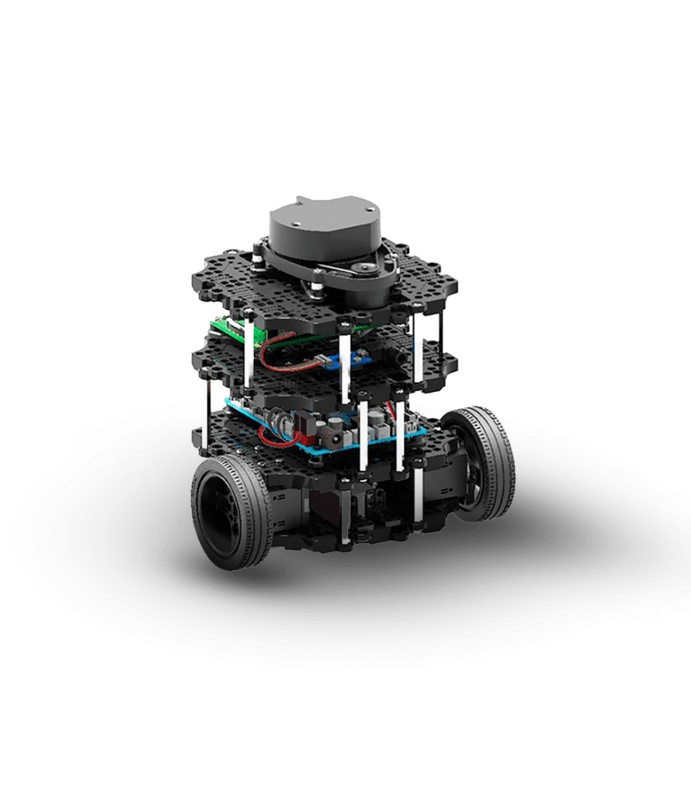

Figure 1 TurtleBot Burger

Above is a figure of the TurtleBot Burger that was used to navigate the maze, which has two Dynamixel servo motors, an OpenCR ARM Cortex-M7 control board, and a Raspberry Pi 3. These came pre-built and were provided by GIU Berlin.

## Software Implementation

Our software had three parts: image processing, path planning, and trajectory planning.

Image processing:

Our project involves creating an Autonomous Robot Maze Navigation System using acuro markers to define key points within a maze. We produced six markers: four for the maze corners, one for the robot, and one for the goal.

   

Figure 3 – Corner 2 Marker

Figure 4 – Corner 3 Marker

Figure 5 – Corner 4 Marker

Figure 2 – Corner 1 Marker

 

Figure 7 – Goal Marker

Figure 6 – Robot Marker

To calibrate the camera, we initially use a 9x6 chessboard image from OpenCV. A calibrated image is then captured using the IP Webcam app, which transforms a smartphone camera into an IP webcam feed, easily accessible via a provided URL. This image is saved as RAW_MAP.png.

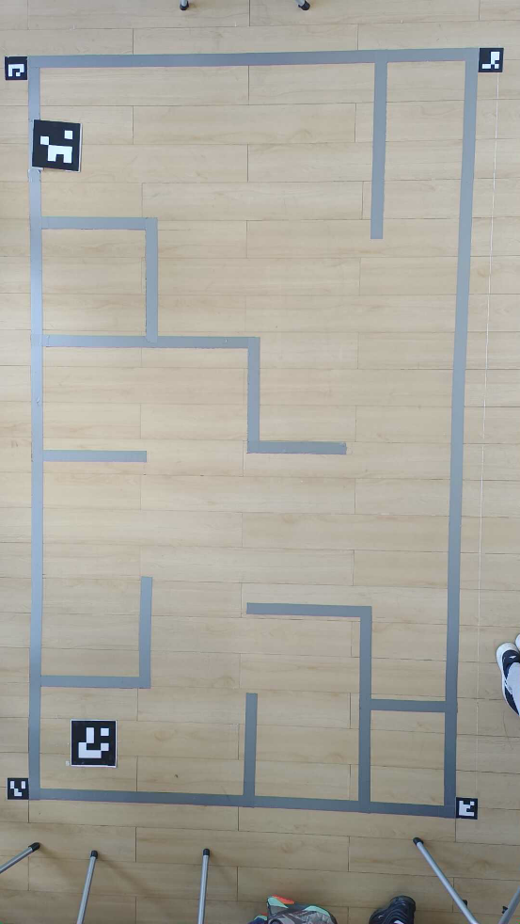

Figure 8 - RAW_MAP.png

In Track_Dec.py, we process the image to locate the markers, identifying their exact corners, centers, and tags, and save this data to a CSV file. Next, Track_Dec_copy.py preprocesses the image using perspective crop data from the CSV file to straighten it and then reprocesses it to determine only the goal and robot positions. Using this data, we generate the map in map.py, starting with color extraction to create a binary map (BIN_MAP)

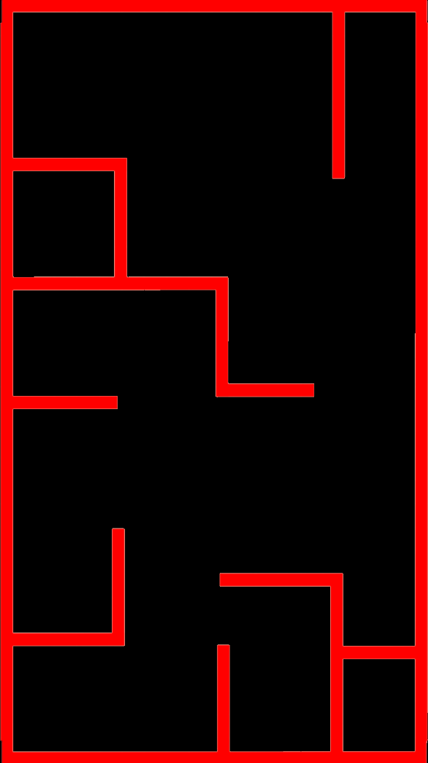

Figure 9 - BIN_MAP.png

where black represents walls and white indicates free space, saved as FIN_MAP.

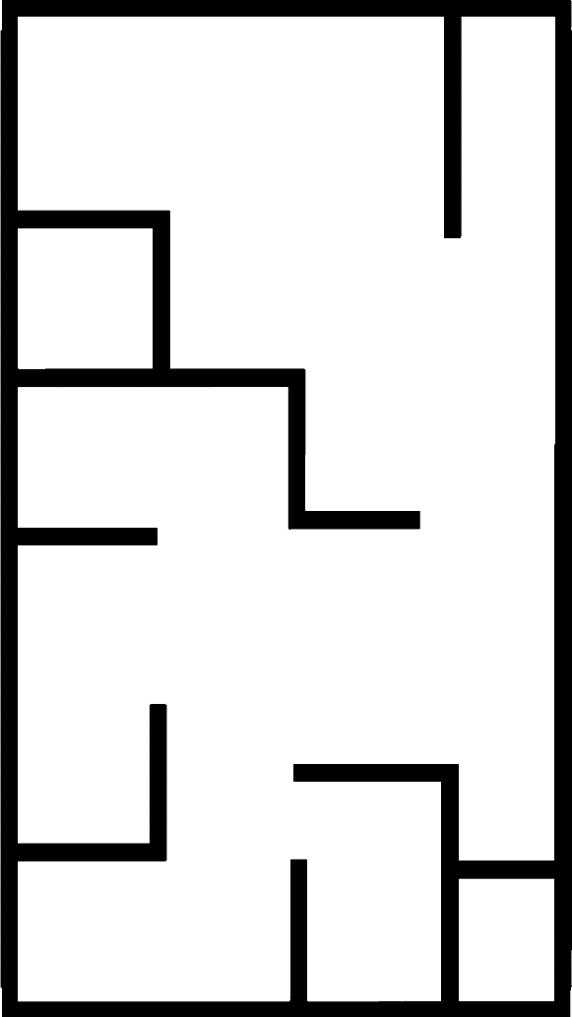

Figure 10 - FIN_MAP.png

This binary image is then read as an array, and we insert goal data based on the robot's size relative to map dimensions, storing the robot's four corner coordinates in Robot.txt. We adjust the map array to include the goal area, saved as MAP_REP.csv and visualized as a PNG. Finally, we calculate the pixel-to-centimeter ratio and the robot's orientation, recording this information in Map.txt. For subsequent operations, only MAP_REP.csv, Map.txt, and Robot.txt are required, with additional data available for debugging and visualization.

The MAP_REP.csv file is then inputted into the path planning algorithm, v2.py, which produces .txt file call path.txt. This file has an array of the coordinates that the robot is supposed to move and the corresponding directions. Following that, it goes through move.py which contains the code for controlling the speed of the robot based on its proximity to the next point. The code controls the motors of the robot so that it speeds up the further away it is, and slows down as it gets closer. The same goes for the angular speed, which is also controlled based on the rotation left to the required angle. These instructions are sent to the motors through ROS to the Raspberry Pi.

## IEEE Standards

IEEE 1872-2015 - IEEE Standard Ontologies for Robotics and Automation

IEEE 1028-2008 - IEEE Standard for Software Reviews and Audits

IEEE 802.11 - Wireless LAN Standards

IEEE 1633-2016 - IEEE Recommended Practice on Software Reliability

# CHAPTER 5: EVALUATION



## Qualitative Analysis and Technical Assessment

This enables the undertaking of qualitative advances in autonomous technology by being able to solve complex, challenging navigational problems. The fact that it has the novel feature of using pre-processed map data in conjunction with the most current path-finding algorithms for efficiency and accuracy is a significant feature. The system has been developed aiming to motivate better operational effectiveness and safety in contexts such as industrial automation and search and rescue. There is a social need for acceptability and trust, and there will possibly even be the need to relate to people inferences of benefits and stability in a true manner. Finally, the project also exemplifies teamwork, as each of the team members brings their respective specialized research to further strengthen and make the project viable.

Technically it applies advanced wall tracking algorithms for the best path finding in the maze, giving the robot great precision in its path with very optimal paths. Pre-processed images for environment mapping make it possible to use more accurate route planning with lesser computational load on the robot at runtime. The overall architecture of the system has very high flexibility, being capable of easily integrating many types of sensors and responding to specific conditions associated with a given challenge. However, since pre-processed data is at its peak and navigation accuracy is highly reliant on map data quality, this approach does not allow for real-time adaption. All in all, this project is an immensely challenging example of sensor integration, algorithm development, and system design.

## Business and Economic Evaluation

The Autonomous Robot Maze Navigation System is laden with several issues but offers promising economic opportunities as well. The research might lead to a product that can approach niche industries like warehouse management, search and rescue operations, and autonomous guided vehicles in those industrial setups that demand navigation solutions highly accurate and effective. In order to succeed, the project value proposition should comprise benefits over existent solutions in terms of cost savings, enhanced effectiveness, and safety. Realization and further growth of the initiative will need the collaboration of providers, industry actors, and technology players. The organization would also have to deal with potential risks, which include high up-front costs of development, technological uncertainty, and a continuous need for innovation to be ahead in the market.

For the industry, the Autonomous Robot Maze Navigation System can be able to inspire enormous savings and higher production. Helping enterprises save money spent on staff, reduce error rates, and increase their operating performance through hard navigation job automation can result in these types of benefits. The advantages hence can create cost savings in different businesses along with profitability. The technology has the potential to boost economic development by opening up new markets and producing jobs in robot development, maintenance, and other support services. To overcome the economic limits that require the project to raise funds for manufacturing costs, research and development, and investment recovery, the autonomous robot must meet a number of economic conditions.

## Social and Environmental Concerns

Social implications of the project involve benefits to the community and employment opportunity creation. Employment displacement could occur following the deployment of autonomous robotics, at worst, especially to those industries that already involve people's use to navigate or use equipment. It is therefore important at the development stage to consider the consequences that may befall workers and find ways to train or assign people whose jobs will have been taken up. There is the chance that people, especially in public or shared environments, will oppose the idea of an autonomous robot being introduced into employment. Existence of worries with respect to questions arising can dampen the social vision, causing people to reject the use of such inventions. To address these concerns and ensure that the benefits of technology are realized while also reducing worries, good communication and community participation are required. In addition, it is of social importance that it is made operational and set to be used by a wide spectrum of users rather than a few.

Environmentally, the design of the project and operation must be sustainable. The materials that are going to be used to make the robot must try to fit to take care of the environment in terms of being biodegradable or rather recyclable in case of maximum disposal. Energy usage is another important consideration; the robot must be built to run effectively in an attempt to reduce its environmental impact. This could also mean optimizing algorithms and hardware for reduced power consumption. The entire lifecycle of the robot, from production and operation to disposal, should ideally be looked into, meaning the robot should be engineered with minimal environmental impact. What is more, it will have to explore what environmental gains might arise, such as whereby it removes the requirement for energy-intensive human navigation systems, as this may balance some of the environmental costs of the project. Steps to cascade improvement down the robot sustainability ladder go a long way in giving the better picture to the environment and in connection to the larger goals for an eco-balanced environment.

# CHAPTER 6: CONCLUSION AND FUTURE WORK



## Conclusion

The main objective of our project was to prototype an effective autonomous maze robot navigation mechanism in a maze that could be performed with minimum external rescuing by humans. This objective has been met by working systematically with design, implementation, and evaluation.

Over the course of the evaluation phase, we found out important needs for successfully navigating, such as precise localization, reliable pathfinding algorithms, and real-time adaptability. We also looked at a variety of technologies and procedures, including Acuro markers for localization, image processing techniques for map construction, and pathfinding algorithms such as wall tracking, as well as filtering in order to optimize the path taken.

Centered on developing a reliable system architecture, the design phase overall was fundamentally significant. We created six Acuro markers, indicating the maze corners, robot starting point, and destination; these markers were reference points required by the system for ensuring accurate localization. We created a camera calibration procedure based on a 9x6 OpenCV chessboard image to enable accuracy in the capture and processing of images.

The system was evaluated based on its accuracy with which the robots traversed the maze using the preprocessed map data and path planning. Our main purpose with success in following the optimal path by the robot is achieved when it shows confidence in not colliding with anything. One thing we could have done better is use a more complex, more efficient path planning algorithm, which would have simplified the filtering process and provided a more optimal path.

## Future Work

**Future work will focus on:**

* Integrating real-time sensor data to adapt to dynamic environments.
* Enhancing pathfinding algorithms with machine learning to optimize navigation.
* Conducting extensive testing in diverse settings to improve robustness and generalizability.
* Implementing additional safety features and fail-safes.
* Developing a user-friendly interface for easier setup and operation.

# REFERENCES

1. Wasti, Abhijan, et al. "Aerial View Based Guidance System." Journal of Innovations in Engineering Education 3.1 (2020): 1-13.
2. Aqel, M. O. A., Issa, A., Khdair, M., ElHabbash, M., AbuBaker, M., & Massoud, M. (2017). Intelligent Maze Solving Robot Based on Image Processing and Graph Theory Algorithms. 2017 International Conference on Promising Electronic Technologies.
3. A Maze Bot. Leonid Keselman et al. Department of Computer Science, Stanford University, Department of Mechanical Engineering, Stanford University, June 12, 2017.
4. https://robotican.net/turtlebot-open-source-personal-research-robot-2/
5. Collar (1947), "The Expanding Domain of Aeroelasticity," Journal of the Royal Aeronautical Society 51-1.
6. Bell Loyed, “Three-dimensional Unsteady flow analysis in vibrating Turbine Cascades”, Durham University, 1999.
7. Jeff Green, PHD Thesis, “Controlling Forced Response of a High-Pressure Turbine Blade”, Royal Institute of Technology, Stockholm, 2006.

# APPENDIX A

Any codes, flowcharts, datasheets or ratings of instruments and equipment can be provided here if needed.